TELEPHONE DIRECTORY OF CENTRAL TOOL ROOM, LUDHIANA

S.N. |  | Name of the Employees | Designation | Room No. | Email id | Telephone No. | Ext. No.
1 | 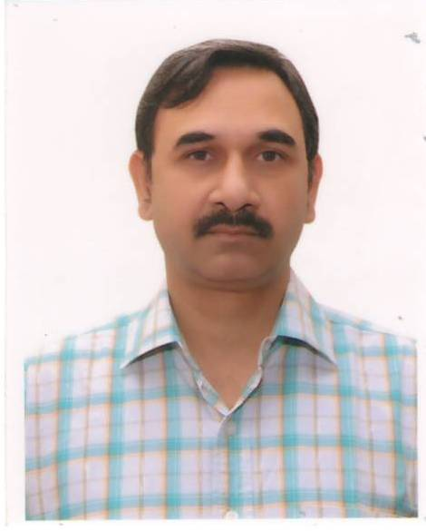 | A.P. Sharma | General Manager | 101 | tcludhiana@dcmsme.gov.in | 2670057 | 221
2 | 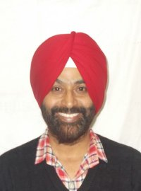 | Sharan Pal Singh Taggar | Manager | Prod. | marketing@ctrludhiana.com / org | 2676166 | 236
3 | 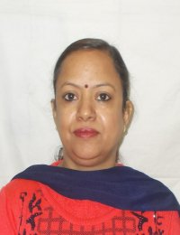 | Neelam Bala | Manager | 13 | marketing@ctrludhiana.com / org | 2670058 | 240
4 | 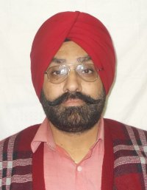 | Jagdeep Singh | Asstt. Manager | Training Shop | training@ctrludhiana.com / org | 2670058 | 256
5 | 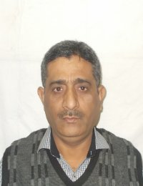 | D.S.Dubey | Asstt. Manager | 120 | marketing@ctrludhiana.org | 2670058 | 233
6 | 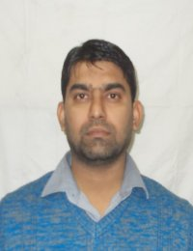 | Kamalooddin | Asstt. Manager | 120 | marketing@ctrludhiana.org | 2670058 | 233
7 | 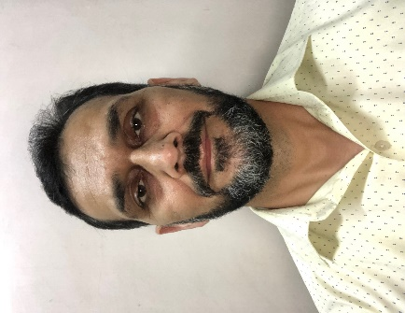 | Vishwa Nath Sharma | Personal Secretary | 103 | info@ctrludhiana.org | 2670057-58 | 222
8 | 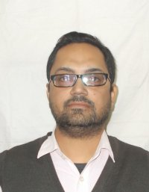 | Rajesh Kumar | Engineer | Training | training@ctrludhiana.com / org | 2670058 | 254
9 | 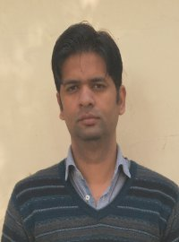 | Anoop Kumar | Engineer | Training | training@ctrludhiana.com / org | 8568073457 | -
10 | 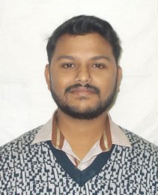 | Mrinankush Datta | Engineer | Training | training@ctrludhiana.com / org | 2670058 | 254
11 | 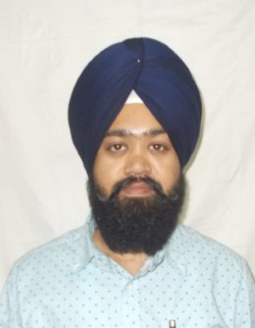 | Sukhwant Singh | Engineer | 15 | training@ctrludhiana.com / org | 2670058 | 251
12 | 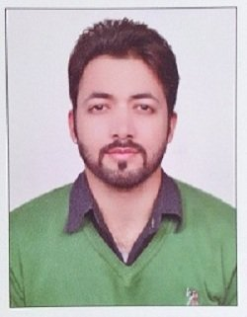 | Amit Kapoor | Engineer | Training | training@ctrludhiana.com / org | 2670058 | 254
13 | 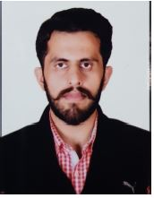 | Ajayveer Singh | Engineer | Prod. Shop | marketing@ctrludhiana.com / org | 2670058 | 236
14 | 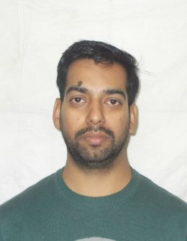 | Jatin Kumar | AADO | 109 | accounts@ctrludhiana.com | 2670058 | 226
15 | 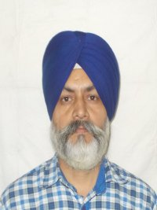 | Jasbir Singh | DAG-II | 120 | marketing@ctrludhiana.com / org | 2670058 | 233
16 | 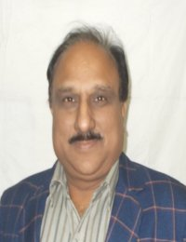 | Ashwani Kumar | TG-I | Training | training@ctrludhiana.com / org | 2670058 | 243
17 | 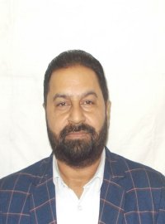 | Ram Krishan | TG-I | Prod. Shop | marketing@ctrludhiana.com / org | 2670058 | 240
18 | 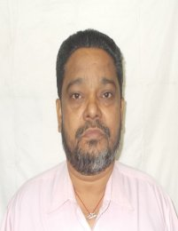 | Himmat Singh | TG-I | Prod. Shop | marketing@ctrludhiana.com / org | 2670058 | 240
19 | 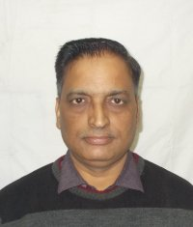 | Devi Dass | TG-I | Prod. Shop | marketing@ctrludhiana.com / org | 2670058 | 240
20 | 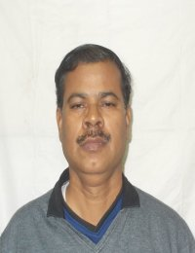 | A.Rama Rao | TG-II | Main store | marketing@ctrludhiana.com / org | 2670058 | 238
21 | 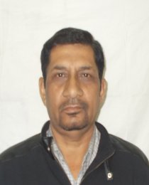 | Tarsem Lal | TG-II | Prod. Shop | marketing@ctrludhiana.com / org | 2670058 | 240
22 | 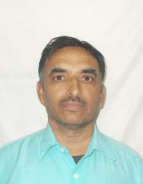 | Surjit | TG-II | Prod. Shop | marketing@ctrludhiana.com / org | 2670058 | 240
23 | 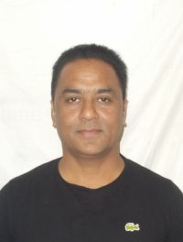 | Surinder Singh - 230 | TG-II | Prod. Shop | marketing@ctrludhiana.com / org | 2670058 | 240
24 | 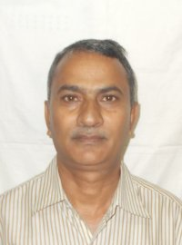 | Dileep Kumar | TG-II | Prod. Shop | marketing@ctrludhiana.com / org | 2670058 | 240
25 | 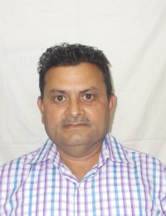 | Balwinder Singh 257 | TG-II | Prod. Shop | training@ctrludhiana.com / org | 2670058 | 240
26 | 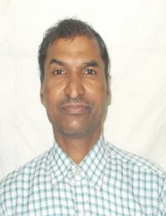 | Bawa Deen | TG-II | Prod. Shop | marketing@ctrludhiana.com / org | 2670058 | 240
27 | 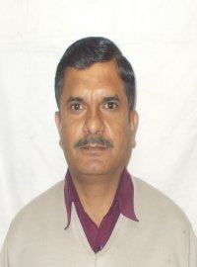 | Balbir Singh 245 | TG-II | Prod. Shop | marketing@ctrludhiana.com / org | 2670058 | 240
28 | 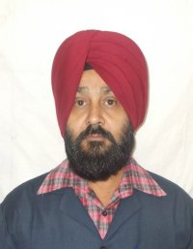 | Balwinder Singh-246 | TG-II | Prod. Shop | marketing@ctrludhiana.com / org | 2670058 | 240
29 | 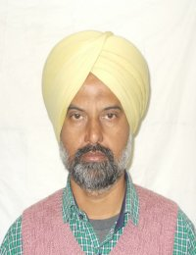 | Sukhwant Singh | TG-II | Prod. Shop | marketing@ctrludhiana.com / org | 2670058 | 240
30 | 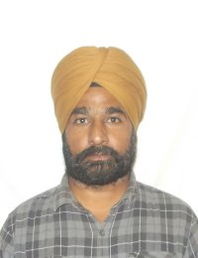 | Manjit Singh 281 | TG-II | Prod. Shop | marketing@ctrludhiana.com / org | 2670058 | 240
31 | 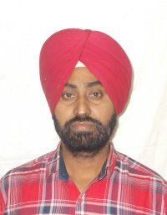 | Iqbal Singh | TG-II | Prod. Shop | marketing@ctrludhiana.com / org | 2670058 | 240
32 | 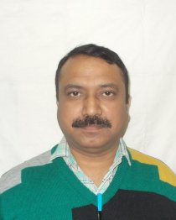 | Kuldeep Raj | TG-II | Training | training@ctrludhiana.com / org | 2670058 | 252
33 | 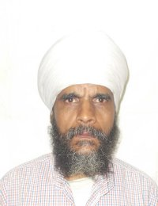 | Harishwar Dutt | TG-II | Training | training@ctrludhiana.com / org | 2670058 | 252
34 | 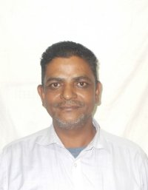 | Gurnam Singh | TG-III | Prod. Shop | marketing@ctrludhiana.com / org | 2670058 | 240
35 | 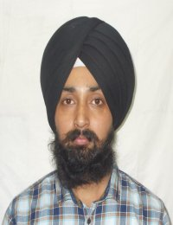 | Amrit Pal Singh | TG-III | Prod. Shop | marketing@ctrludhiana.com / org | 2670058 | 240
36 | 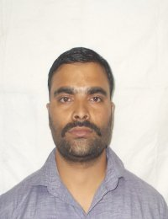 | Rajeev Ram | TG-III | Prod. Shop | marketing@ctrludhiana.com / org | 2670058 | 240
37 | 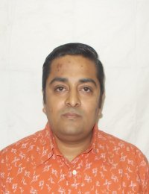 | Amrendra Kumar | TG-II | Prod. Shop | marketing@ctrludhiana.com / org | 2670058 | 240
38 | 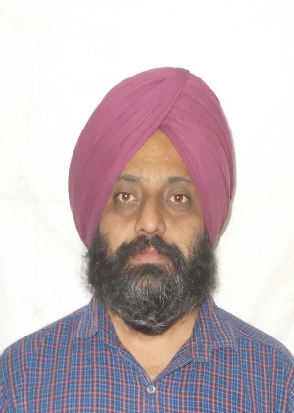 | Baljinder Singh | TG-II | HT. Shop | marketing@ctrludhiana.com / org | 2670058 | 242
39 | 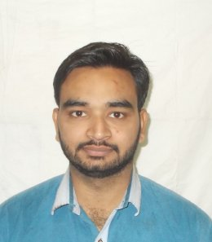 | Rahul Saini | TG-III | Prod | marketing@ctrludhiana.com / org | 2670058 | 240
40 |  | Ajay Sharma | TG-III | Q.C | marketing@ctrludhiana.com / org | 2670058 | 241
41 | 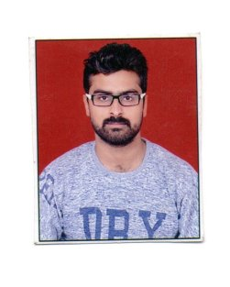 | Vibhanshu | TG-III | Training | training@ctrludhiana.com / org | 8700140059 | -
42 | 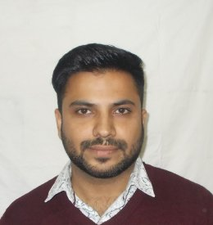 | Anubhav Mehta | TG-III | Training | training@ctrludhiana.com / org | 2670058 | 239
43 | 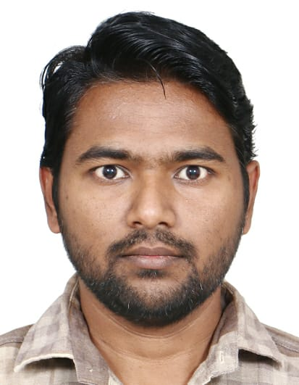 | Shiv Kumar | TG-III | Training | training@ctrludhiana.com / org | 7015032982 | -
44 | 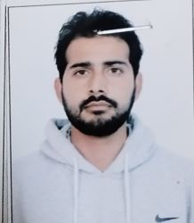 | Aman | TG-III | Training | training@ctrludhiana.com / org | 9068685449 | -
45 | 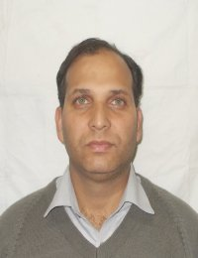 | Anil Kumar | UDC | 14 | marketing@ctrludhiana.com / org | 2670058 | 242
46 | 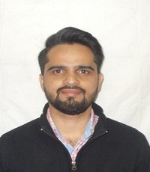 | Mandeep Singh | LDC | 104 | admn@ctrludhiana.com | 2670058 | 232
47 | 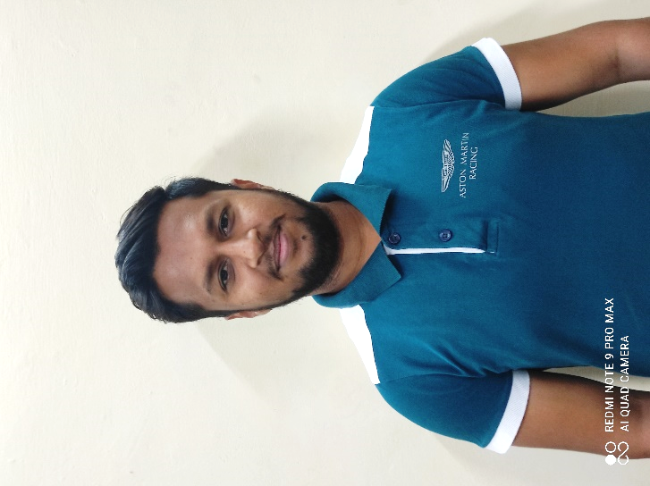 | Paras Garg | LDC | 109 | purchase@ctrludhiana.com | 2670058 | 237
48 | 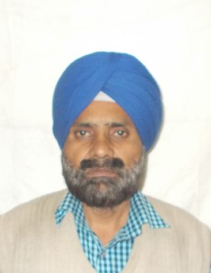 | Balvir Singh | Driver | 104 | info@ctrludhiana.org | 2670058 | 232
49 | 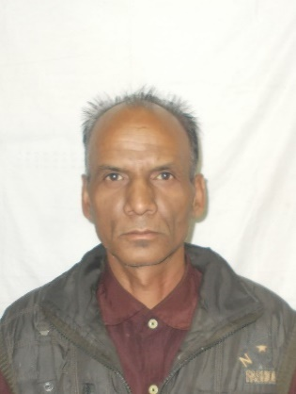 | Paramjeet Lal | MTS | 104 | info@ctrludhiana.org | 2670058 | 232
50 | 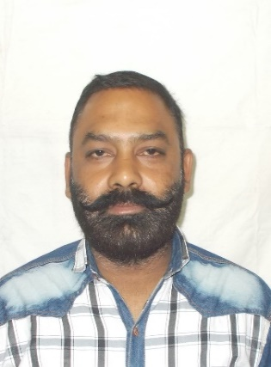 | Deepak Kumar | MTS | HT. Shop | marketing@ctrludhiana.com / org | 2670058 | 238
51 | 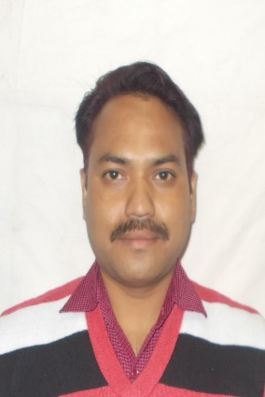 | Sandeep Thapa | MTS | Prod Shop | marketing@ctrludhiana.com / org | 2670058 | 238

